[ZANG] - [Chuanjie]

Student ID: 699382953

[chuanjiezang@gmail.com](mailto:chuanjiezang@gmail.com)

**Final project**

### **ALL Pseudocode：Final Project.txt**

**Flowchart of the login process：**

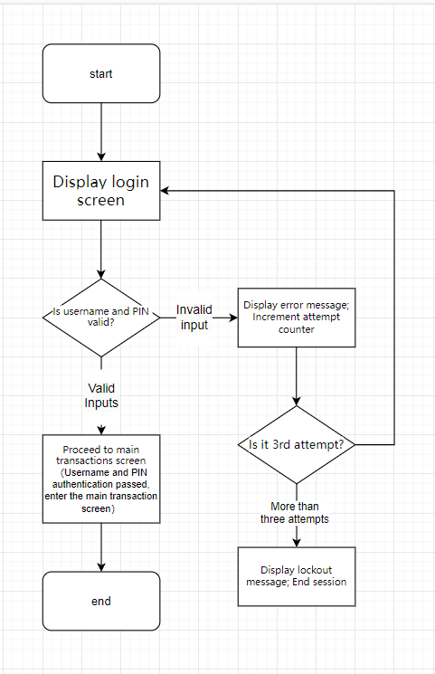

**Main Trading Screen:**

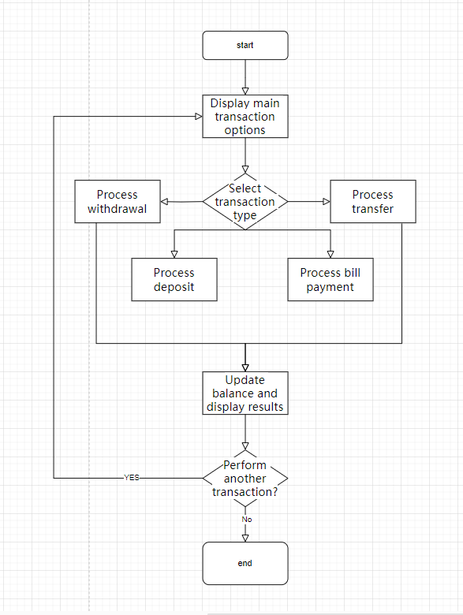

### **Administrator Screens:**

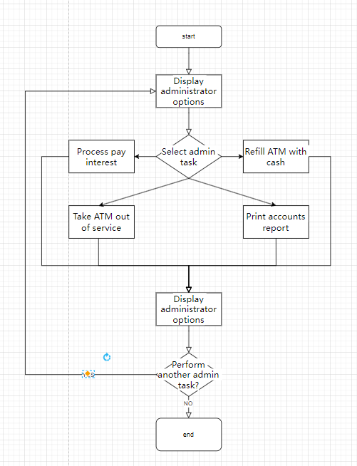

### **Wireframe Design:**

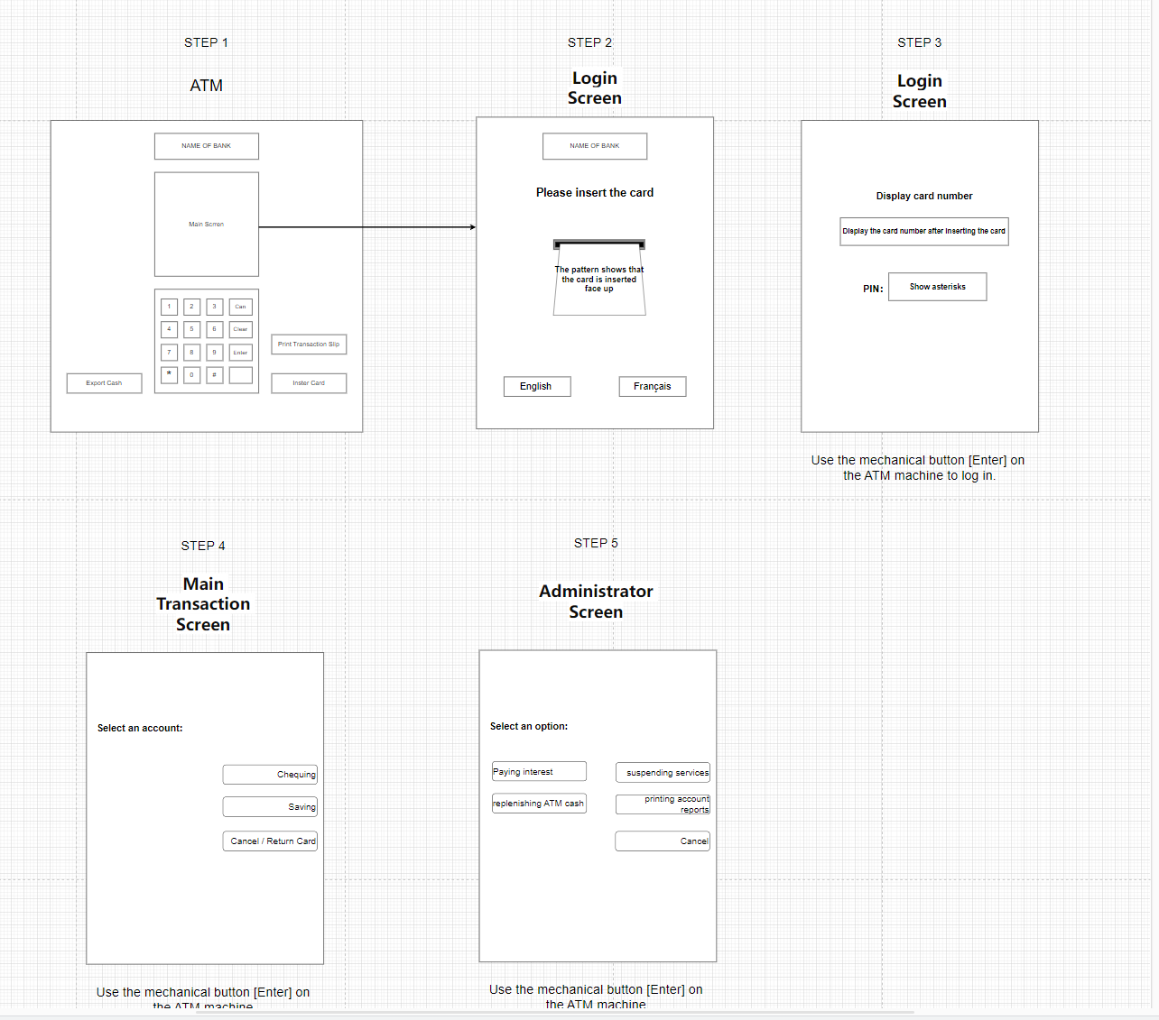

### **Storyboard**

**Process Description**:

1. After the user enters his/her username and PIN through the login screen, depending on the validation results, he/she is either taken to the main transaction screen (for regular users) or to the administrator screen (if the login information matches that of the administrator account).
2. From the main transaction screen, the user can select different bank transaction operations and upon completion of each operation, the screen displays the status of the transaction (Success or Failure) and asks the user if they want to continue with other transactions.
3. The Administrator screen allows the administrator to perform system level operations such as replenishing ATM cash or suspending ATM service, etc. The operation status is also displayed when the operation is completed.
4. The Exit button on any screen ends the current session and returns to the login screen so that a new user or administrator can log in.

Object Dictionary

|  |  |  |  |
| --- | --- | --- | --- |
| **Object Type** | **Screen** | **Affected Variables** | **Invoked Procedures/Methods/Functions** |
| Input Field | Login Screen | Username, PIN | Validate user information |
| Button | Login Screen | None | Submit login information |
| Button | Main Transaction Screen | Selected transaction type | Execute corresponding banking operation |
| Button | Administrator Screen | Selected admin operation | Execute corresponding admin operation |
| Display | All Screens | None | Show error messages or transaction results |
| Exit Button | Main Transaction Screen / Administrator Screen | None | End session and return to login screen |